B.Tech. Computer Science & Engineering (AIML)

Course: Project based Learning

Course Code: AI3170

## “ dRIVERS DROWSINESS DETECTION ”

By

**ANISH SHARMA: 219310042**

**AVINSH K UPADHYAY: 219310238**

**DIVYADITYA SINGH JHALA: 219310304**

Under the guidance

of

**Dr. Lokesh Malviya**

**Assistant Professor (Senior Scale)**

Department of Computer Science & Engineering, School of Computing & Information Technology Manipal University Jaipur, Jaipur

**Department of Computer Science & Engineering**

**School of Computing & Information Technology**

**Manipal University Jaipur, India**

NOVEMBER 2023

**Table of Contents:**

* Certificate
* Abstract
* Introduction
* Methodology
* Results
* Conclusion
* Future prospect
* Acknowledgements

# 1.Certificate

This is to certify that the project titled **“DRIVERS DROWSINESS DETECTION”** is a record of the bona fide work done by **ANISH SHARMA, AVINASH K UPADHYAY, DIVYADITYA SINGH** submitted for the partial fulfilment of the requirements for the completion of the PROJECT BASED LEARNING(AI3170) course in the Department of Computer Science & Engineering of Manipal University Jaipur, during the academic session 2021-2022.

|  |
| --- |
| *Signature of the mentor* |
| Dr. Lokesh Malviya  Assistant Professor (Senior Scale)  Department of Computer Science & Engineering |

# 2.Abstract

Drowsiness and fatigue are one of the main causes leading to road accidents. They can be prevented by taking effort to get enough sleep before driving, drink coffee or energy drink, or have a rest when the signs of drowsiness occur. The popular drowsiness detection method uses complex methods, such as EEG and ECG. This method has high accuracy for its measurement but it need to use contact measurement and it has many limitations on driver fatigue and drowsiness monitor . Thus, it is not comfortable to be used in real time driving. This paper proposes a way to detect the drowsiness signs among drivers by measuring the eye closing rate.

This project describes on how to detect the eyes and in a video recorded from the camera in real-time. In the video, a person is driving the car, and a webcam will be place in front of the driver. The video will be recorded using the webcam to see the transition from awake to fatigue and finally, drowsy. The designed system deals with detecting the face area of the image captured from the video. The purpose of using the face area so it can narrow down to

detect eyes within the face area.

The parameters of the eyes and mouth detection are created within the face image. The video was change into images frames per second. From there, locating the eyes and mouth can be performed. Once the eyes are located, measuring the intensity changes in the eye area determine the eyes are open or closed.

If the eyes are found closed using the EAR (Eye Aspect Ratio) less than 0.25, it is confirmed that the driver is in drowsiness condition

3.Introduction

Drowsiness is a state of near sleep, where the person has a strong desire for sleep. It has two distinct meanings, referring both to the usual state preceding falling asleep and the chronic condition referring to being in that state independent of a daily rhythm. Sleepiness can be dangerous when performing tasks that require constant concentration, such as driving a vehicle. When a person is sufficiently fatigue while driving, they will experience drowsiness and this leads to increase the factor of road accident.

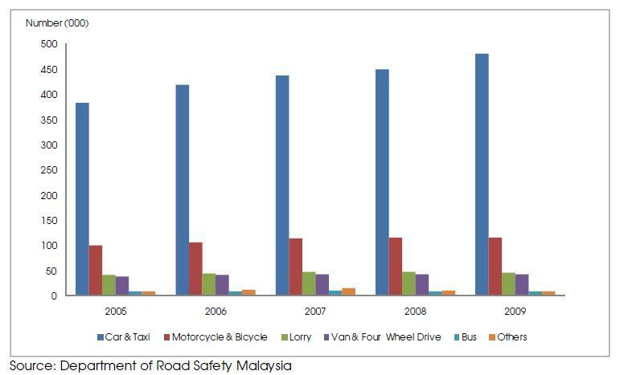

**Figure 1: Statistic of Road Accident from 2005 to 2009**

Figure 1 shows the statistic of road accident in Malaysia from the year 2005 to 2009 provided by MIROS (Malaysia Institute of Road Safety). The numbers of vehicles involved in road accident keep increasing each year. From Figure 1, car and taxi type of vehicles shows about nearly

400,000 cases of road accident have been recorded. It keeps increasing every year and by the year.

2009, it shows the number of road accident were recorded by MIROS are nearly 500,000

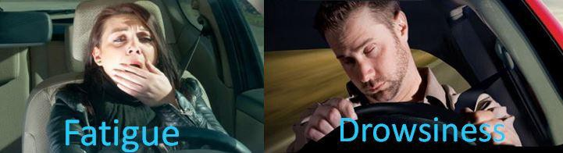

**Figure 2: Examples of Fatigue & Drowsiness Condition**

The development of technologies for detecting or preventing drowsiness while driving is a major challenge in the field of accident-avoidance system. Because of the hazard that drowsiness presents on the road, methods need to be developed for counteracting its affects.

The aim of this project is to develop a simulation of drowsiness detection system. The focus will be placed on designing a system that will accurately monitor the open or closed state of the driver’s eyes and mouth. By monitoring the eyes, it is believed that the symptoms of driver's drowsiness can be detected in sufficiently early stage, to avoid a car accident. Yawning detection is a method to assess the driver’s fatigue. When a person is fatigue, they keep yawning to ensure that there is enough oxygen for the brain consumption before going to drowsiness state. Detection of fatigue and drowsiness involves a sequence of images of a face. This detection method is based on the Eye Aspect Ratio(EAR) eyes which refers to the amount of eye closed.

**3.1 Problem Statement**

Current drowsiness detection systems monitoring the driver’s condition requires complex computation and expensive equipment, not comfortable to wear during driving and is not suitable for driving conditions; for example, Electroencephalography (EEG) and Electrocardiography (ECG), i. e. detecting the brain frequency and measuring the rhythm of heart, respectively.

A drowsiness detection system which uses a camera placed in front of the driver is more suitable to be use but the physical signs that will indicate drowsiness need to be located first to come up with a drowsiness detection algorithm that is reliable and accurate. Lighting intensity and while the driver tilts their face left or right are the problems occur during detection of eyes and mouth region.

**3.2. Objectives**

* To suggest ways to detect fatigue and drowsiness while driving.
* To study on eyes and mouth from the video images of participants in the experiment of driving simulation conducted by MIROS that can be used as an indicator of fatigue and drowsiness.
* To investigate the physical changes of fatigue and drowsiness.
* To develop a system that use eyes closure and yawning as a way to detect fatigue and drowsiness.

# 4. Methodology

This chapter will explain about the method that has been taken to reach the objectives of the project and a closer look on how the project is implemented. It is the analysis of each stage that will be faced to complete this project. Each selection and achievement of the method taken that has been implement in this project will be explained for each stage until the project is success.

**4.1. Software requirements**

* Python
* Libraries
  + Numpy
  + Scipy
  + Dlib
  + OpenCv

**4.2. Implementation**

* In our program we used Dlib, a pre-trained program trained on the HELEN dataset to detect human faces using the pre-defined 68 landmarks (figure below).

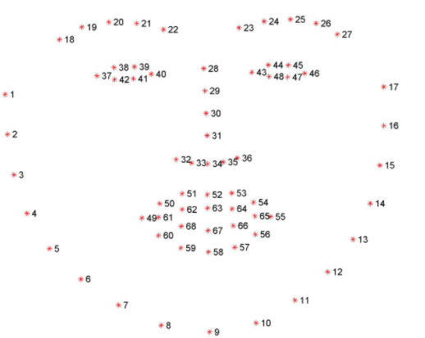

* After passing our video feed to the dlib frame by frame, we are able to detect left eye and right eye features of the face.

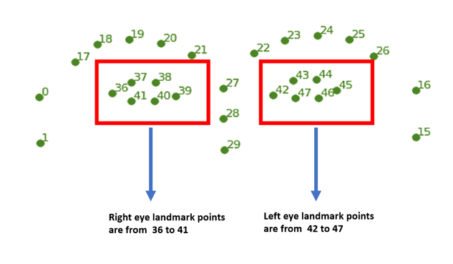

* Now, we drew contours around it using OpenCV.
* Using SciPy’s Euclidean function, we calculated sum of both eyes’ aspect ratio which is the sum of 2 distinct vertical distances between the eyelids divided by its horizontal distance.

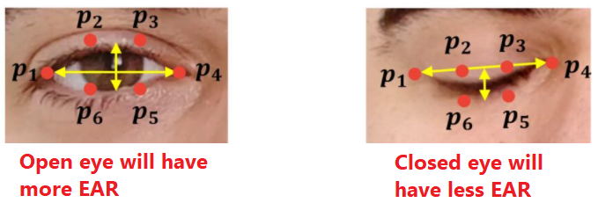

* EAR(Eye Aspect Ratio) is calculated as:

* Now we check if the aspect ratio value is less than 0.25 (0.25 was chosen as a base case after some tests). If it is less an alarm is sounded and user is warned.

# 5. Results

# Screenshots of Project

# Drowsy person

# 

# Non-Drowsy person

# 6. Conclusions

# It completely meets the objectives and requirements of the system. The framework has achieved an unfaltering state where all the bugs have been disposed of. The framework cognizant clients who are familiar with the framework and comprehend its focal points and the fact that it takes care of the issue of stressing out for individuals having fatigue-related issues to inform them about the drowsiness level while driving.

# 7. Future Prospects

# The model can be improved incrementally by using other parameters like blink rate, yawning, state of the car, etc. If all these parameters are used it can improve accuracy a lot.

# We plan to further work on the project by adding a sensor to track the heart rate in order to prevent accidents caused due to sudden heart attacks to drivers.

# Same model and techniques can be used for various other uses like Netflix and other streaming services can detect when the user is asleep and stop the video accordingly. It can also be used in an application that prevents user from sleeping.

# 8.Acknowledgements

It is a great pleasure and an immensely enlightening experience for us to undertake this project. We have made efforts in through the process, and this would not have been possible without the support and guidance of our teachers and companions. We are highly indebted to our mentor ‘Dr. Lokesh Malviya’ for his guidance and constant supervision as well as for providing necessary information regarding the project. His constant willingness to share his vast knowledge made us understand this project and its manifestations in great depths.

Our thanks and appreciation extend to everyone who supported and aided in any possible way. Their cooperation and encouragement kept us motivated throughout.